- What is SDLC ?
A software development life cycle is a series of steps or phases that provide model for development.

- What is software testing?
Software testing is a process used to identify the correctness, completeness and quality of developed computer software.

- What is agile methodology?
Agile means delivering working software in small parts with continues feedback and improvement.
- Agile key point
- iterative incremental model
- daily meeting
- continuous improvement
- continuous feedback and testing
- fast and flexible delivery
- customers are involved in every phase
- work divided into small parts

- What is SRS ?
A software requirement specification is a complete description of the behaviour of the system to be developed.

- What is Oops?
Oops means object oriented programming. that includes class , object and encapsulation .

- Write Basic Concepts of oops?
- Class
- Object
- Inheritance
- Encapsulation
- Polymorphism
- Abstraction

- What is object?
Object gives permission to access functionality of class.

- What is class?
It is a collection of data member and member functions.

- What is encapsulation?
Encapsulation is Wrapping of data

- What is inheritance ?
To drive attribute of some other class

- What is polymorphism ?
Polymorphism means one name multiple form

- Draw Usecase on online bill payment system (paytm).
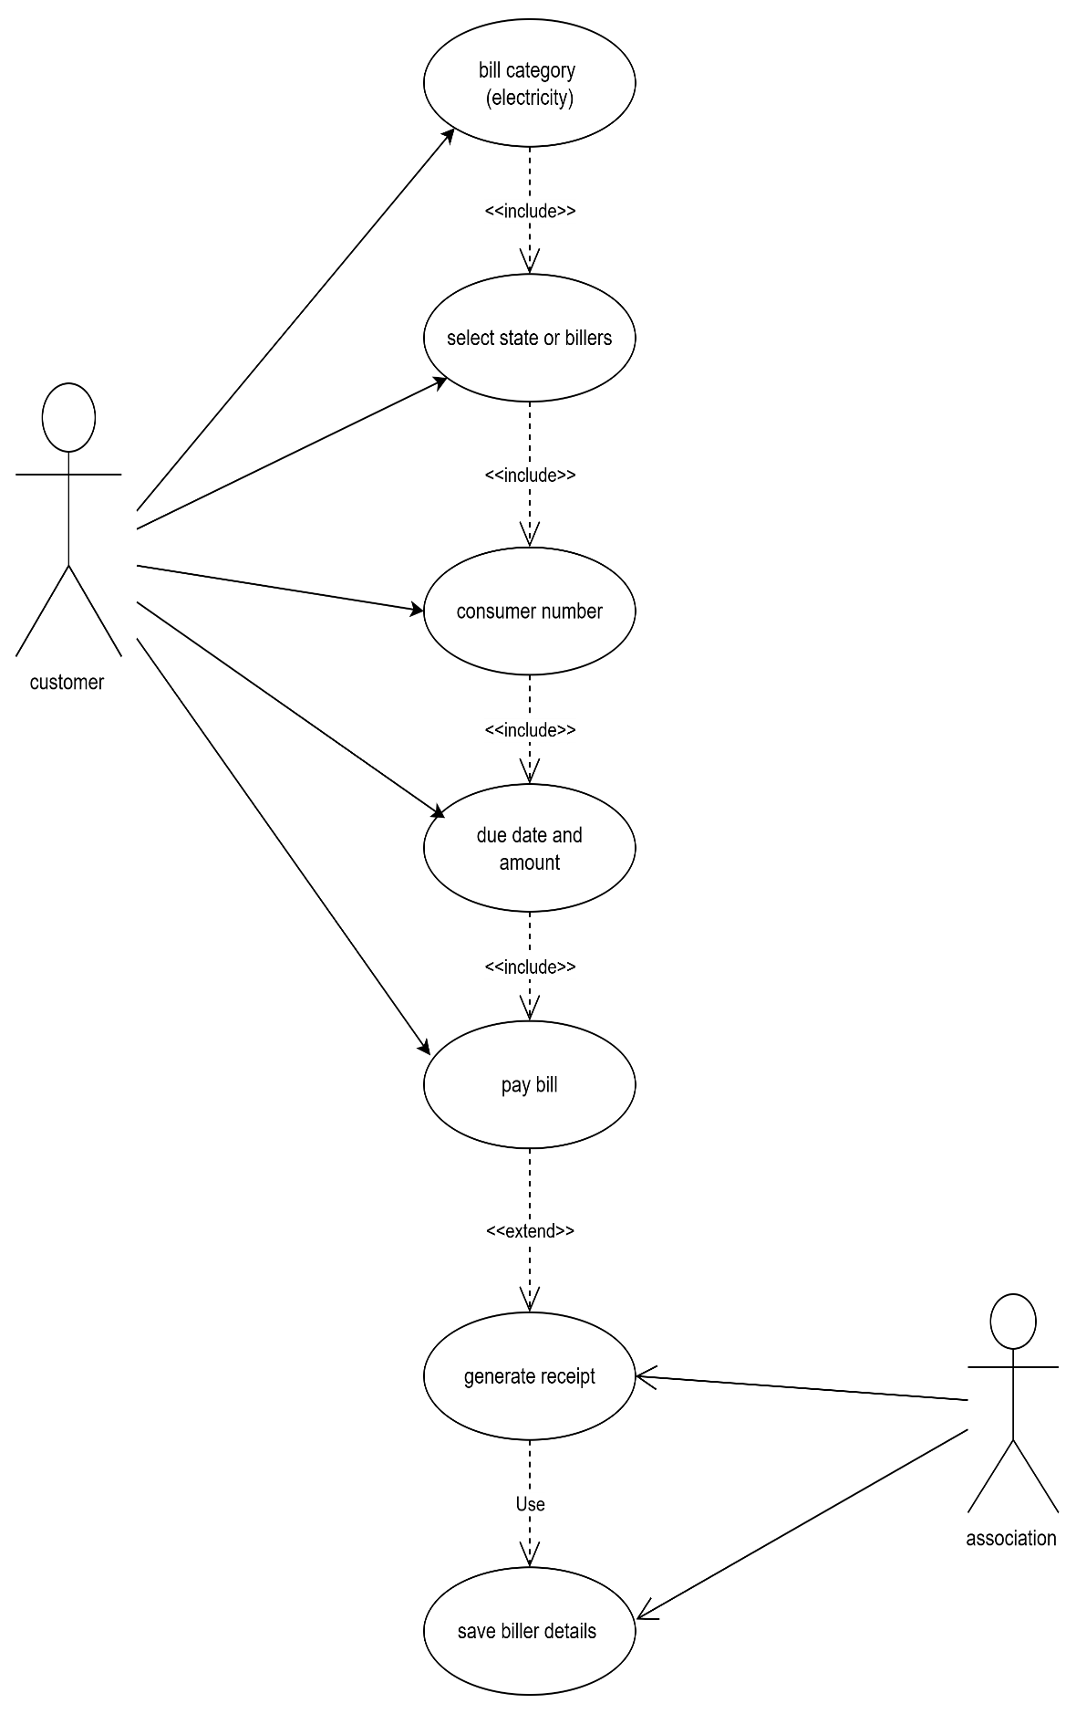

- Draw Usecase on banking system for customers.

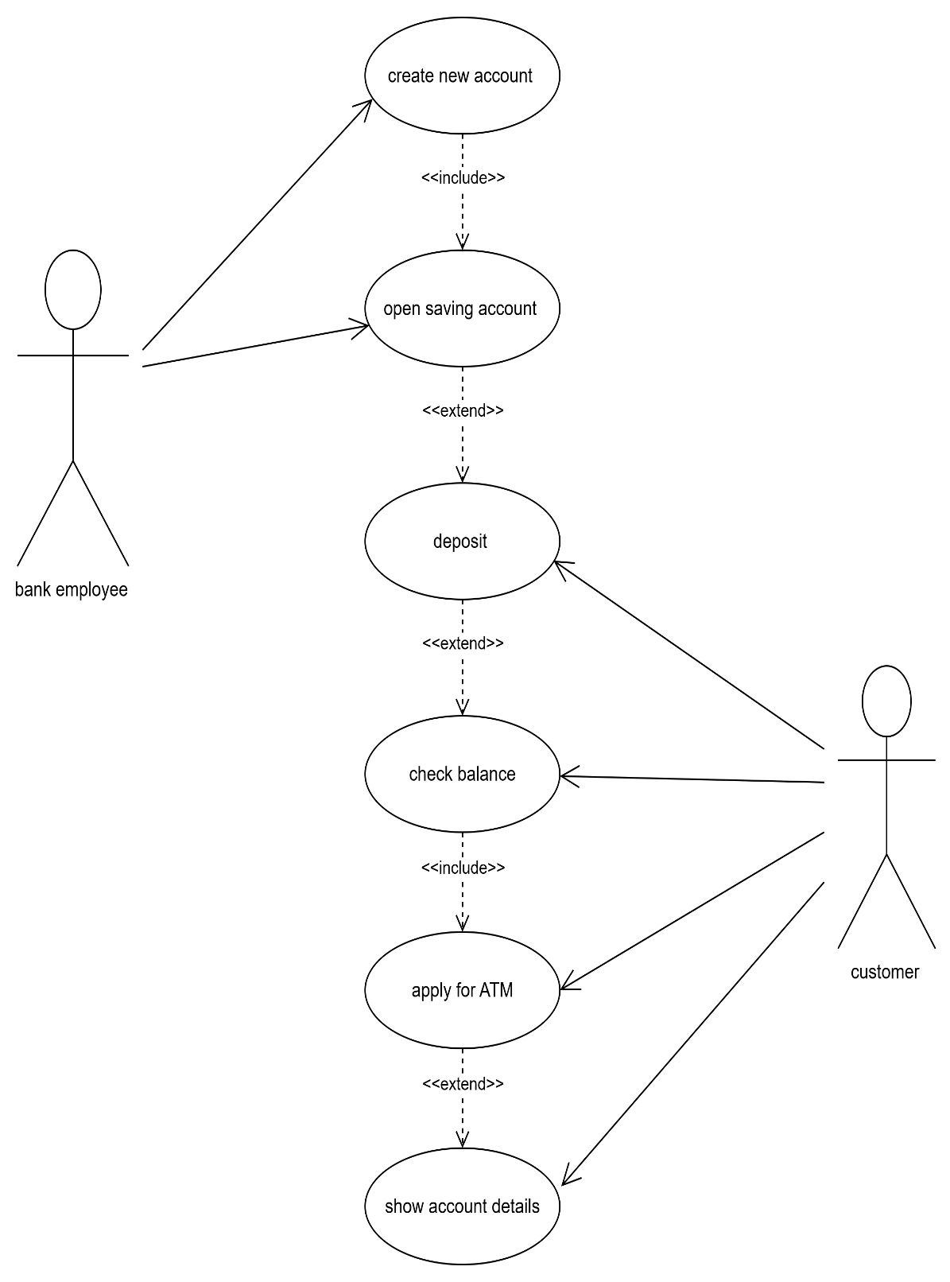

- Draw Usecase on Broadcasting System.
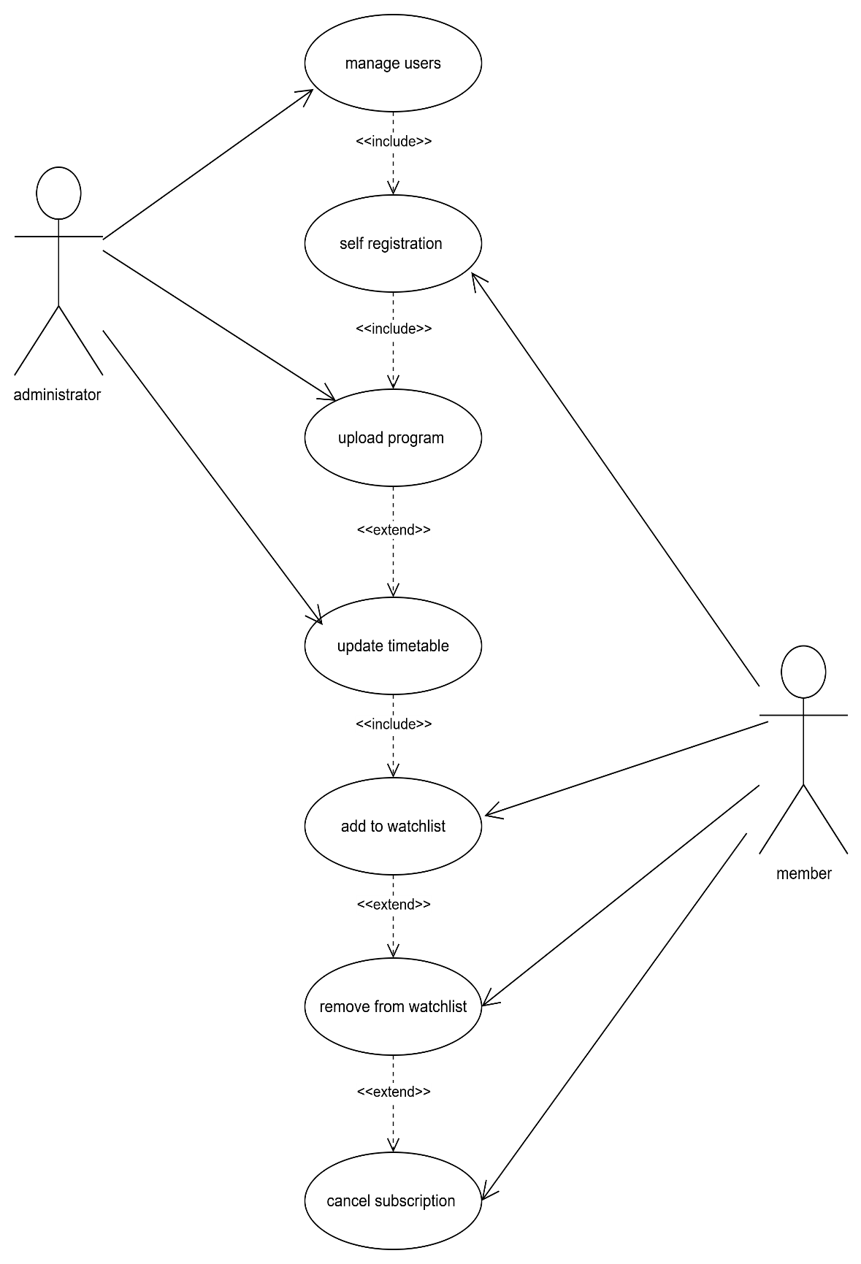

- Write SDLC phases with basic introduction.
- Requirement gathering and analysis
- Designing
- Implementation
- Testing
- Deployment
- Maintenance
- Requirement – collect details from client about the project
Analysis – to analyze the requirement and covert CRS into SRS
- Designing – to prepare design as requirement
- Implementation -for coding
- Testing and deployment – to verify the completeness , correctness and quality of the developed software and deploy it.
- Maintenance :-
Correcting – to repair the detect.
Perfective – to add a new feature
Adaptive – test in new platform

- Explain Phases of the waterfall model .
6 phases:-
- Requirement gathering and analysis – collect details from client and analyze the requirement
- Designing – prepare design according to requirement
- Implementation – coding according the requirements
- Testing – to verify the completeness , correctness and quality of software
- Deployment – testing and verification
- Maintenance – repair defects , add new feature, and test in new platform

- Write phases of spiral model .
spiral model phases :-
- Planning
- Risk analysis
- Engineering
- Customer evaluation

- Write agile manifesto principles .

- Explain working methodology of agile model and also write pros and cons.
Agile means delivering working software in small parts with continues feedback and improvement.
- Prons –
- fast and flexible delivery
- high customer satisfaction
- continuous improvement
- easy to change requirements
- reduced risk
- enhanced product quality

- Draw usecase on OTT Platform.
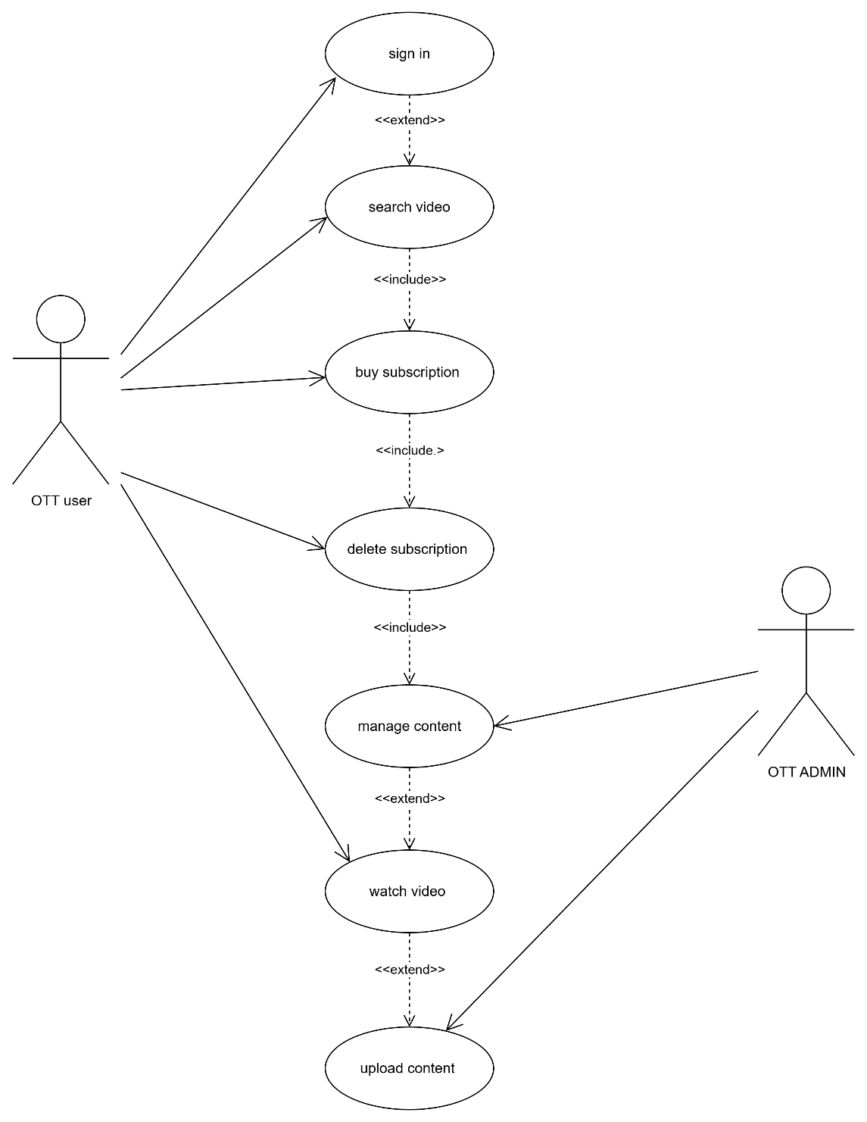

- Draw usecase on E-commerce application.

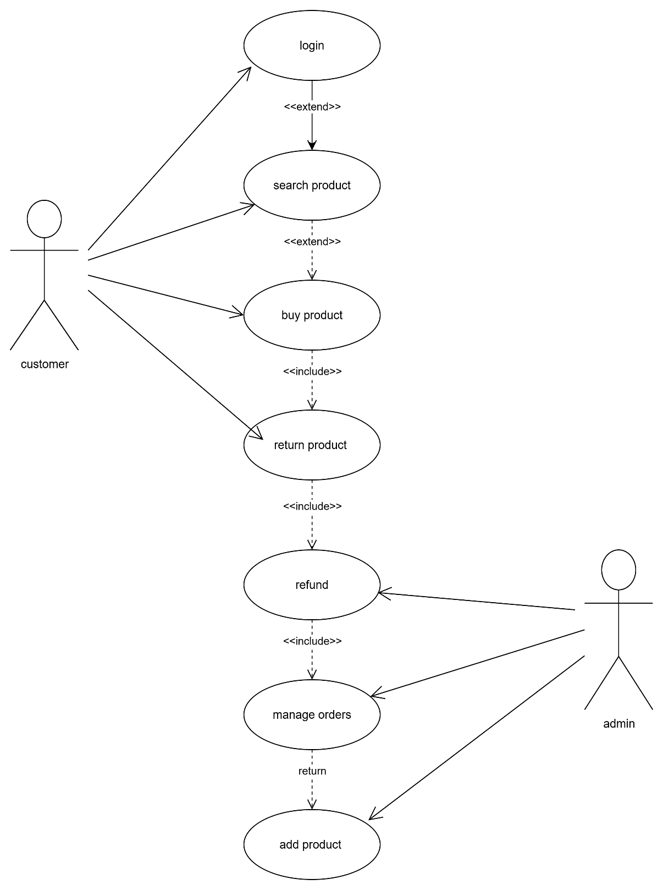

- Draw usecase on Online shopping product using payment gateway.
